**PSP Estimating Worksheet**

1. **Conceptual Design**

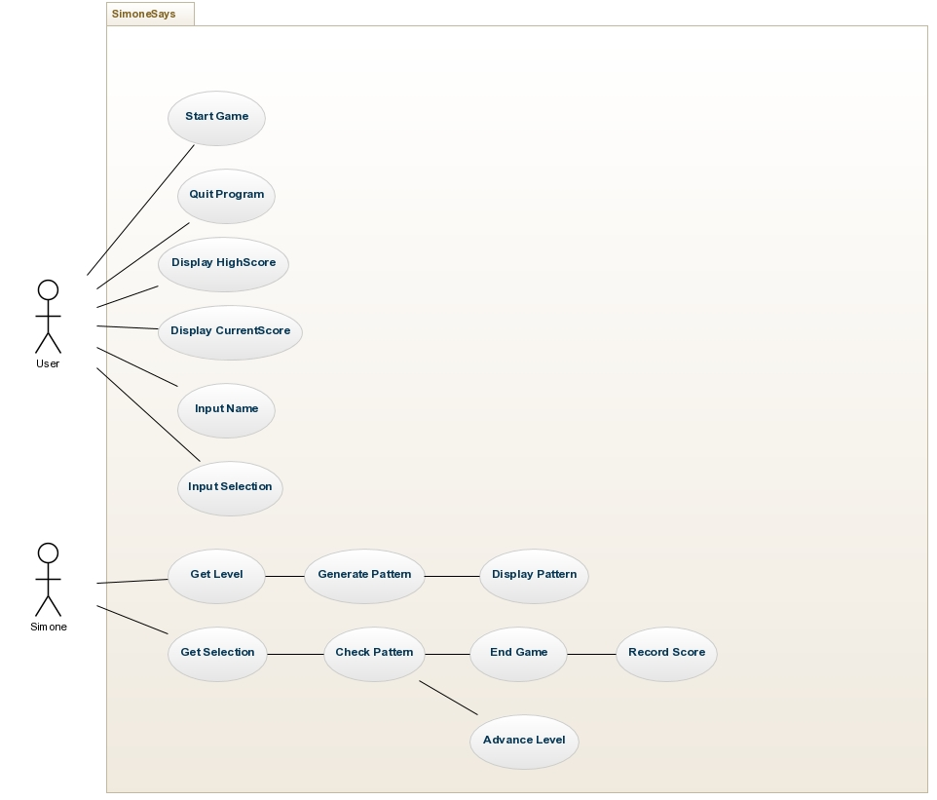

|  |  |
| --- | --- |
| **2. Module Estimates** |  |
| **Module Description** | **Estimated Size** |

GUI 250

Simone 300

Player 100

Highscore 50

**TOTAL ESTIMATED SIZE: ___700___________**